The Helping Hand

Daniel Samarin

Advisor: Dr. Zizhong Wang

**Introduction**

The Helping Hand is a project that is designed with a crowdfunding model but unlike kickstarter and gofundme which are primarily for investing in businesses or entrepreneurial ideas, The Helping Hand is specifically designed to help people in need. Helping those in need is something that truly makes a difference, and can be just the boost someone needs to get on their feet. One major problem with charities and the idea of Charity in general is that many monetary donation services do a good job at showing those tarnished by poverty or disaster but are usually poor at showing how the money that those individuals donate go to help the ones in need. By skipping the middle man and donating directly to those who need the help most, can hopefully give potential donors the assurance they need to feel confident that their monetary donations are actually helping people. By development of this project it gives those in need and those willing to help a direct link to each other by way of online requests.

By creating a safe and secure way for those in need to reach out for help allows for a higher chance that someone will come to their aid and help them through their situation, whatever that may be.

**Design**

To begin the structure of the Helping Hand, I hand-sketched out a rough outline of how I wanted the system structured. By doing this I realized I needed 6 unique pages being, a homepage, a request page, a donate page, a profile page, a login page, and a signup page. I planned out the layout and structure of how each page would look before ever typing a line of code. I believe the logical transition from page to page was sound and let to a well flowing system.

Tables:

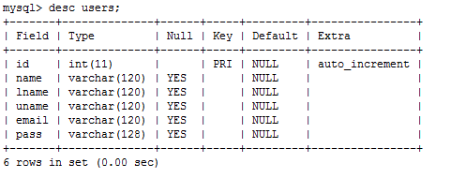I created a table named ‘users’ to store user account information. Thus allowing me have a permission structure, that denies access to certain pages if a user is not logged in, as well as personalize displayed information in the user profile page.

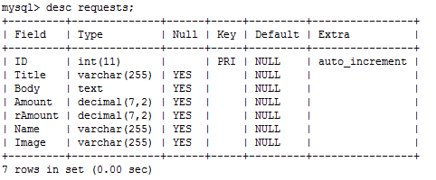The next table I created was the ‘requests’ table to store request information. This information is displayed to the Donate page, for which potential donors can view and determine whether a cause is worthy of donation.

Website Flow:

After creating the necessary tables, I began to hand sketch out the flow of The Helping Hand. After some consideration and brainstorming this became the decided flow of the website. Blue arrows meaning natural progression, and red meaning log out.

Home Page

Sign Up

Log In

Request

Donate

Profile

**Case Study**

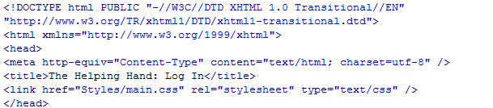**Header Code:**

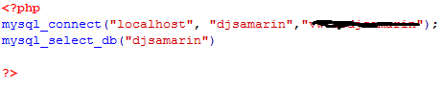

The first picture shows HTML header text that ensures browser compatibility across the popular three browsers (Chrome, Firefox, Internet Explorer). The 2nd picture is my config.php file which is required by all pages to access the MySQL tables. The Styles/main.css line is the path to my CSS sheets that style all of the web pages.

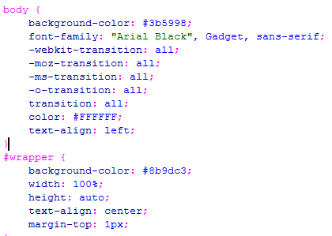**main.css example:**

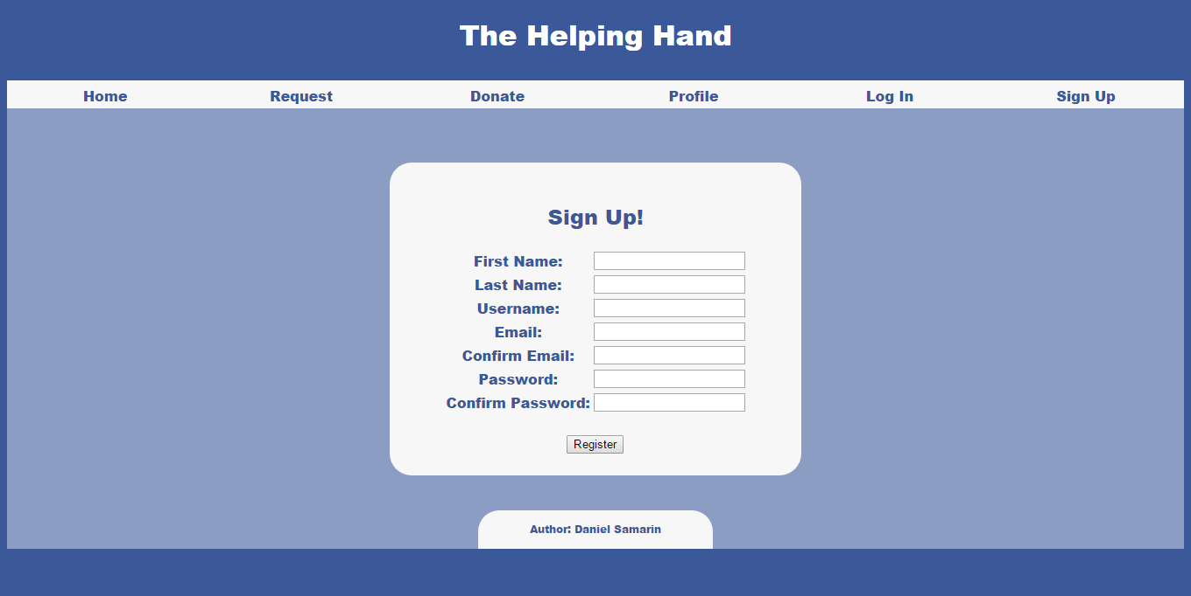**SignUp.php**

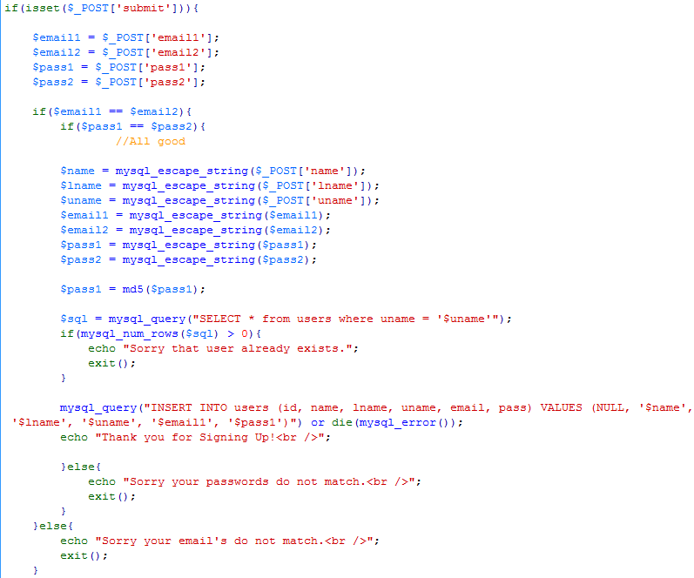

This page takes the information that is filled into these fields and adds the information into the ‘users’ database. However, before the information gets added there are some check cases to ensure that there aren’t duplicate usernames, to ensure passwords match and to ensure emails match. This also runs the passwords through MD5 encryption to ensure a secure system.

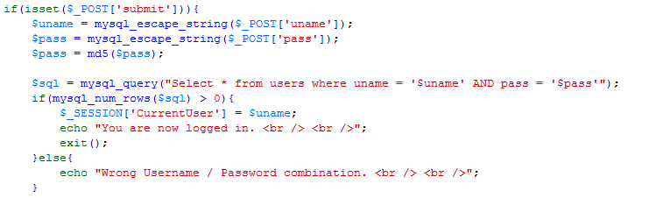**LogIn.php**

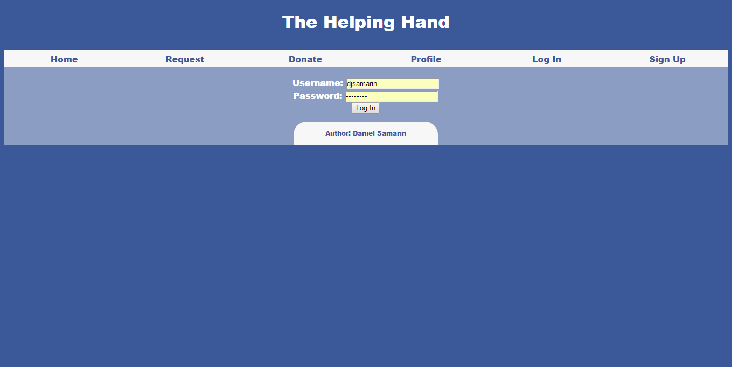This code checks the entered username and password to check that the user exists. If it exists a session is created. If not an error is prompted.

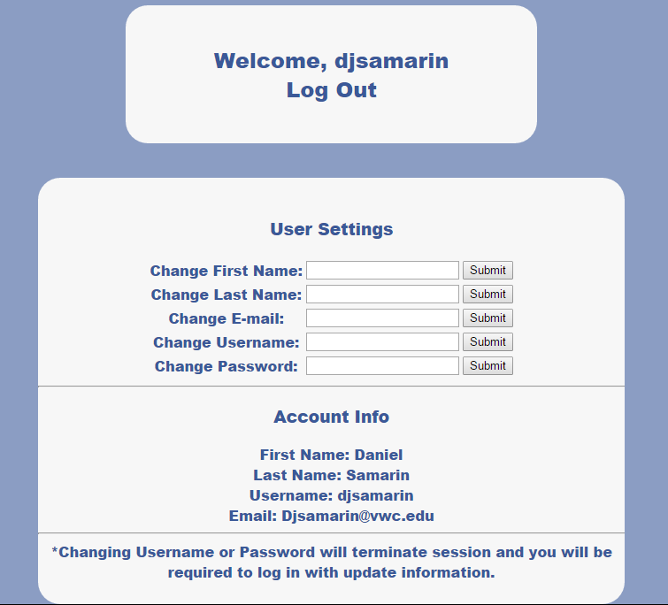**Profile.php**

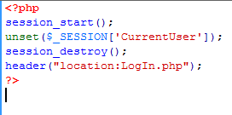This section of profile.php links to logout.php shown below.

****This script terminates the session and redirects back to LogIn.php.

The upper section of the div contains a form that lets you change user information and updates it directly into the MySQL database. The 2nd half of the div contains your active Account information for the individual user.

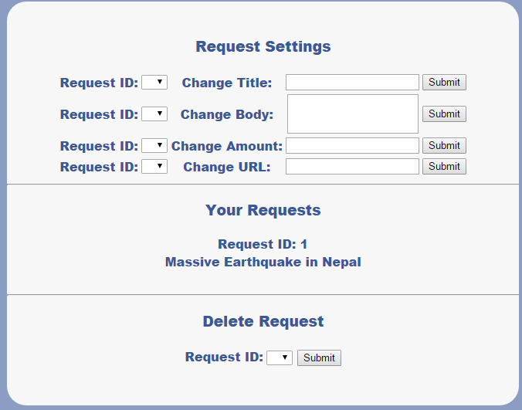The upper half of the div allows you to change the information of your active requests, the 2nd section shows your active requests, and third section allows you to delete a request.

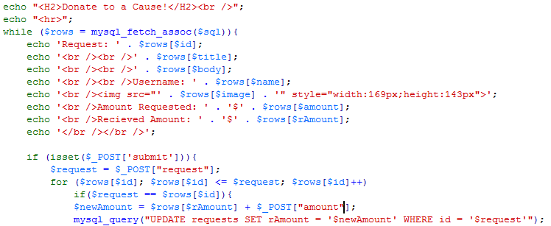**Donate.php**

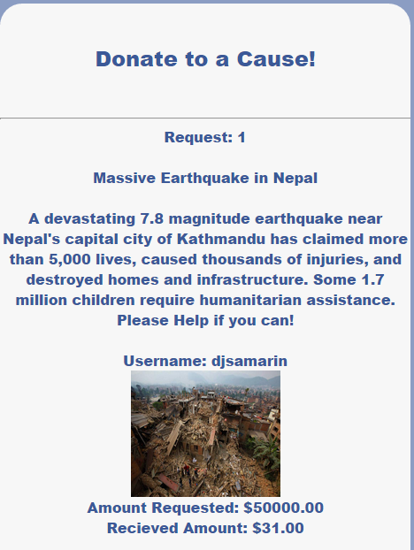

This code displays the entire row of information in the form of a request. Which is looped for the amount of request are in the ‘requests’ and shown. The Donate box updates the amount of received money which is added together with the previous amount to display the new received total.

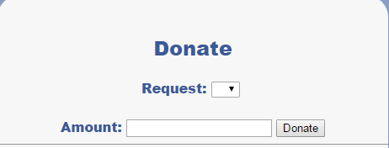

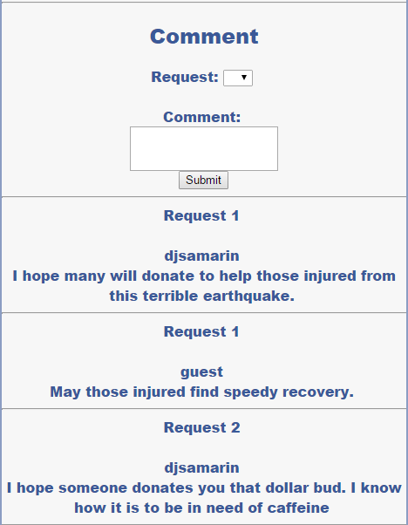When submitted the comment box stores your username and the request for which you are commenting on and then displays your comment and your username. Anyone who visits the site can see these displayed comments.

**Request.php**

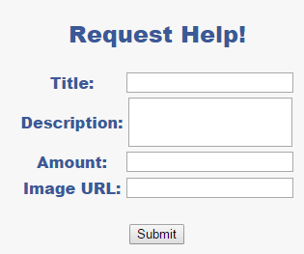

The request page displays a simple form which stores the information into the ‘requests’ table.

**Conclusion**

This project was a very interesting way that tested my ability to problem solve on the fly as many bug occurred. Identifying and fixing these bugs further increased my understanding of MySQL and PHP. I learned to modify my ideas on the fly to develop a good looking fully functional system.

**References**

Dev.mysql.com (2015) MySQL :: MySQL 5.6 Reference Manual. [online] Available at: http://dev.mysql.com/doc/refman/5.6/en/

Php.net (2015) PHP: PHP Manual - Manual. [online] Available at: <http://php.net/manual/en/index.php>

Web Programming with PHP/MySQL : Dr. Wang